Student wellbeing and engagement guidelines
Background:
Initially developed in 2009, and revised in 2015 and 2018, Carlton Primary’s Student wellbeing and engagement policy draws on our experience with the School Wide Positive Behaviour Support Program and Trauma Informed Practice in Education.
The information contained in this document is shared with the school community throughout the year via :-
Student information booklet
Newsletters
Parent forums
Parent/Teacher meetings

School context:
Our Guiding Principle
At Carlton Primary School we take pride in being a caring school that strives to meet the needs of all students through a rich and engaging curriculum.
This guiding principle underpins the teaching and learning philosophy of our school, which recognises that every child is unique and the educational needs of each will be different. The school’s capacity to inspire and engage each child to fulfil their potential is a key to the success of the school.
Values
The following values underpin everything that we do at Carlton Primary School.
Achievement
- Developing lifelong learning skills
- Nurturing a spirit of enquiry
- Fostering confidence, persistence, independence
Relationships
- Building strong partnerships between school home and community
- Developing interdependence, resilience and self reliance
- Promoting effective and open communication
Respect
- Building an environment of co-operation
- Engaging in interactions that are mutually respectful
- Encouraging positive interactions and a sense of belonging
Diversity
- Respecting individual and cultural differences
- Valuing the experiences of our diverse community
- Providing a curriculum which builds on students’ experiences

Rationale for guidelines
We recognise that while we may not be able to counter the negative influences of the wider society, schools should nevertheless take steps to make their environment a safe and nurturing place that assists children to overcome any personal and social difficulties they may face. In this way children have the best opportunity to take full advantage of the curriculum which is available to them.
Carlton Primary School maintains an emphasis on the following:
- Re-enforcement of positive behaviour
- Building Positive self esteem
- Increased joint decision making between students and teachers
- Educate students in positive community values
- Respect toward self, others and the environment
- Co-operative skills
- Skill building for positive behaviours

Rights and Responsibilities
Students, teachers and families have the right to :
- Feel safe and secure
- Be a respected and valued member of the school community
- To have personal and school property respected
- To experience a positive teaching and learning environment
Students, teachers and families have the responsibilities of :
- communicating in a positive and respectful way
- behaving in a way that is safe and caring toward others
- demonstrating respect toward themselves and others
- caring for property of themselves, others, and school
- cooperating and participating
- to work together to support children to build the skills they need to make positive choices to support learning.

How we implement the student wellbeing and engagement guidelines
Rights and responsibilities form the basis of the school’s expectations. The expectations are listed to protect students, parents and teachers, and to provide a framework for implementing our rights and responsibilities.
Expectations of behaviour for CPS students, staff, parents and carers, and volunteers
- We speak and listen politely to everyone.
- We allow others to work, learn and play without interruption and interference.
- We respect and care for all school property (your own, other’s and the school’s).
- We follow teacher instructions.
- We walk and play sensibly and safely inside and outside the school building.
- We participate in to a whole school approach to student wellbeing and engagement
- We treat everyone with dignity and respect.
When incidents occur all students will be dealt with in a fair way and will have their version of events listened to. Everyone is treated fairly, everyone has a voice.

The structure for promoting and implementing student wellbeing and engagement guidelines across the school includes:
- The guidelines are applicable across the whole school, and are enacted in individual interactions, as well as on a class level.
- All teachers and support staff will focus on positive behaviour of students
- Class agreements are negotiated in the classroom and based on whole school expectations
- Teachers respond to individual student capacity with regard to behaviour. Teachers work with students and the wellbeing team to build student capacity to support learning behaviours
- Where practicable, restorative practices will be implemented e.g.: if a student drops papers on the ground, the negative consequence is to pick up papers; if a student upsets another student, they will make a plan to repair the relationship
- There is a hierarchy of consequences for inappropriate behaviour
- Teachers will consistently reflect on their own teaching – content, mode of delivery and handling of behaviour (appropriate and inappropriate)
- Teachers will always maintain a focus on a sense of inclusion
- At the first school assembly of the year, promote and reinforce the importance of school rules and expectations
- Each year class agreements shall be established early in the school year, in consultation with students in each learning area. These will be based on the whole school expectations and be written in a language appropriate to the age and English proficiency of the children
- Specialist teachers to also develop and display a set of class agreements
- Class agreements will be clearly displayed in the classroom, and a copy of the class agreement to be sent home for parents to read
- Fundamentals of the whole of school approach to student wellbeing and engagement will be linked in with the curriculum wherever possible, for example, as part of the Resilience, Rights and Respectful Relationships curriculum.
- Where appropriate, visual aids will be used to help explain the rules. E.g. photographs and illustrations, raindrops and rainbows
- Specialist teachers participate in the whole school approach to skill building to support student engagement and wellbeing
- The school will impress upon the senior students that they are role models of expected behaviour for all of the children at the school

Responding to student behaviour may include:
Teachers will focus on acknowledging positive learning behaviours, and students will be supported to build the skills they need to be able to make positive behaviour choices.
Acknowledgement of positive student behaviour choices includes, but is not limited to:
Individual
- A raindrop, linked with the 5 learning dispositions
- A rainbow for kindness
- Student of the day
- Stickers, certificates, awards, stamps, stars
- Verbal praise by teachers
- Praise written on student’s work
- Print names in the newsletter
- Letters / phone calls / emails to parents
- Inform Principal of good behaviour
- Activity (earned) time
- Visit other teacher / class for praise
- Extra time on favourite activity – e.g. computer or drawing
- Student of the week or other positive award to be presented at assembly
- Principal’s award

Class
- Organisation of group / class activity e.g.: barbeque, special lunch, concert, party, fun sports
- Game outside / inside
- Grade of the week for assembly, by specialist teachers
- Other reward system as devised by teacher

School
- Special incursions
- Excursions
- Special lunch, e.g. barbeque
- Fun sports day

Responding to behaviour that impedes learning may include:
- When children struggle to make positive behavioural choices, teachers need to address this to maintain a safe and positive teaching and learning environment for all students, teachers and visitors to our school.
- Responses to student behaviour choices that impede learning include, but are not limited to:
- Non-verbal warning. E.G a stern look, move towards the student, name on board
- Verbal warning – name student, name behaviour, question behaviour, explain to the student what the inappropriate behaviour was
- Reset the student using the reset process (attached)
- Call parents/carers to explain what has happened, or to request that they come to the school
- In school suspension – principal’s decision. Parents notified, DEECD suspension form completed
- Home suspension – principal’s decision. Parents notified, DEECD suspension form completed
Note: Use of corporal punishment is prohibited and not deemed appropriate or helpful.

Responding to extreme behaviour
The definition of extreme misbehaviour includes:
- Wilfully inflicting physical harm on another person or property
- Repeated overt refusal to do as the teacher requests
- Any behaviour which is so severe that it stops the whole class from proceeding.
Teachers will call on wellbeing staff to assist in cases of extreme behaviour. In these the cases, leading or restraining a child may be appropriate in cases where there is risk of harm to any child or adult, refer to Framework for the reduction and elimination of restraint and seclusion in Victorian government schools (below).
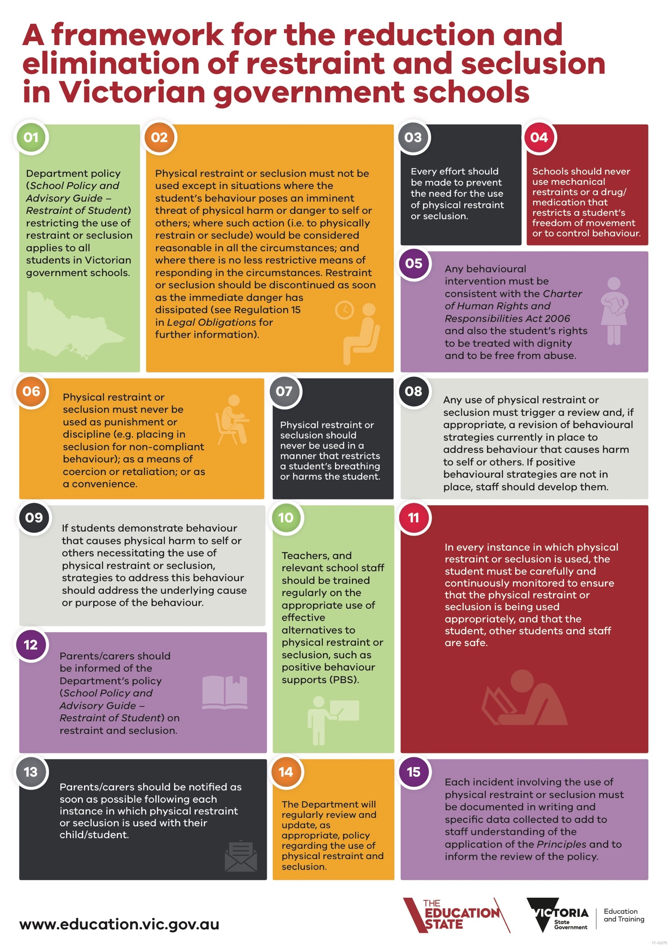
Process for extreme behaviour in the classroom
The pink ‘I need help’ card is sent to the office to be handed to the Principal or Wellbeing Team member. If these people are not available the Office Manager is to broadcast the following message:
“Would Julie and any teacher available immediately go to room…..”
Teachers responding to this call may:
- Assist in the situation
- Remove the student
- Remove and/or supervise the class
- Take the class to give the teacher a short break if required

The student concerned will be removed from the classroom and taken to the office. An ‘in school’ suspension (i.e.: the child does not return to his/her class) will remain in force until the parents have been notified. A behaviour conference will be held with the Principal / Student Wellbeing team, parents, child, class teacher and other appropriate school personnel (i.e. school psychologist) to decide what action is to be taken. A behaviour contract may be drawn up with the student / parent / teacher.
An ‘in school’ suspension is usually in the Principal’s office, but may be in the wellbeing office or another classroom.
Restraint will be avoided except where safety is compromised.
Playground rules
In addition to students following whole school expectations. Other outside rules include:
- Follow the yard duty teacher’s instructions
- Play safely in the designated area and allow other children to play safely without interference
- Use acceptable language
- Respond to bells in a timely manner
- Stay within the yard boundaries
- Resolve conflicts peacefully or seek the help of the yard duty teacher.

Teachers might respond to playground behaviour choices with:
- Verbal praise
- Recognition at assembly or a raindrop or rainbow to be on display
- Walking with the yard duty teacher for a specified time
- Time out at an appropriate place in the playground – usually in the picnic area

Process for extreme behaviour in the playground
- If the yard duty teacher requires assistance, use the portable phone to call for assistance (instructions on the phone) or the pink card in the yard folder.
- Child is removed from the playground
- ‘In school’ suspension procedures follow
- Yard duty teacher fills out appropriate forms

Note: Yard duty teacher is to take aid bum bag and portable phone outside
Out of School expectations
On excursions and interschool sport, in addition to students following whole school expectations out of school rules include:
- Stay safe and be sensible when travelling
- Remain with your class / group
- Respect others and all property
When these behaviour expectations are not met, teachers may implement consequences such as:
- Verbal warning given
- Stay with the teacher for a given time
- Remain with the teacher for the rest of the excursion
- Severe misbehaviour may result in contact with the school
- Banned from next excursion and parent notified

Bullying, racism, sexism, and harassment
Students have the right to be in a secure environment.
All forms of bullying, racism, sexism and harassment are not tolerated at Carlton Primary School, and will be treated very seriously.

References:
“I feel happy when I get to be with you” Trauma informed practice in education at Carlton Primary School. Rebecca Harris, 2016
Victorian Charter for Human Rights https://www.humanrightscommission.vic.gov.au/human-rights/the-charter
Making SPACE for learning. Australian Childhood Foundation, 2012
Klassroom Kaleidoscope. Foundation House 2007
Effective Schools Are Engaging Schools. State of Victoria 2009
Learning Behaviour Principles and Practice Department for Education and Skills. UK 2006

